Visit Report: Ramgati Upazila Health Complex, Lakshmipur
Date of Visit: 13/09/22; Time: 1:00 PM.
Visitor: Dr. Md. Emdadul Haque, National Consultant (SSK) &
Dr. Nazmur Rahman Sajib. Junior National Consultant (SSK)

Objectives of the visit:
1. To assess the progressive development of the quality of health care
2. Discussion about the importance of quality of health care.
3. Formation of quality improvement committee (QIC)
4. Improvement of the quality by implementing the building blocks of C-J Model.

Activities:
1. We arrived at Ramgoti UHC at 1:00 pm and participate in a discussion meeting regarding the importance of quality of health care with UH&FPO, RMO and other members of Quality Improvement Committee (QIC) in the conference room. Dr. Nazmur Rahman Sajib discussed about the importance of quality of health care by a power point presentation & Dr. Emdadul Haque discussed about the building blocks of C-J Model. We also discussed with them about SSK program and the overall situation of health complex.
2.We met with the Upazilla Chairman, as he came to the UHC. He assured us that he will take part in the renovation of labour room, OT room and build two cabins in the health complex. He also assures us a water ambulance for the people of Char-Abdullah should be donated by Upazilla Parisad very soon.
3. We observed the development of UHC's healthcare services while performing a site inspection of the hospital. We have seen lot of improvements, such as those we had suggested on our earlier visit on 1st August 2022, including improvements to the cleanliness, beautification, and waste management systems. They have started to perform C-Section by the support from district authority.
The positive changes are shown below:
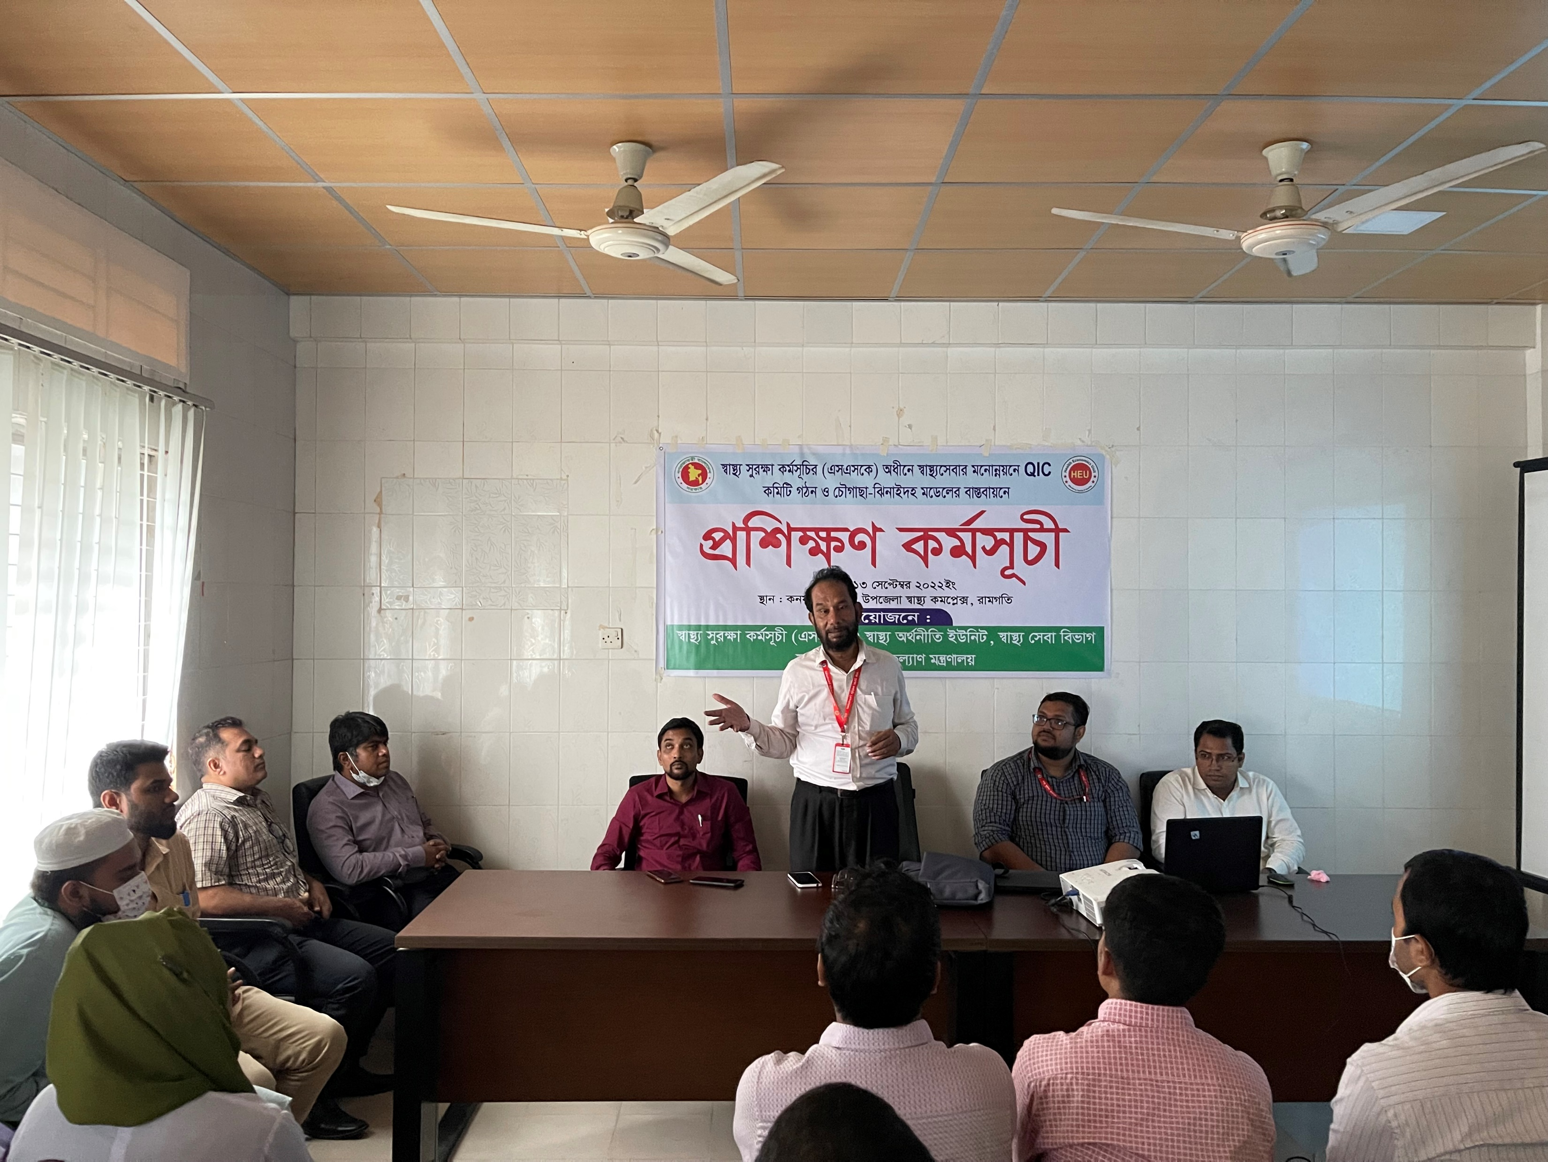

Fig-1: Training on Quality of Care and formation of QIC committee

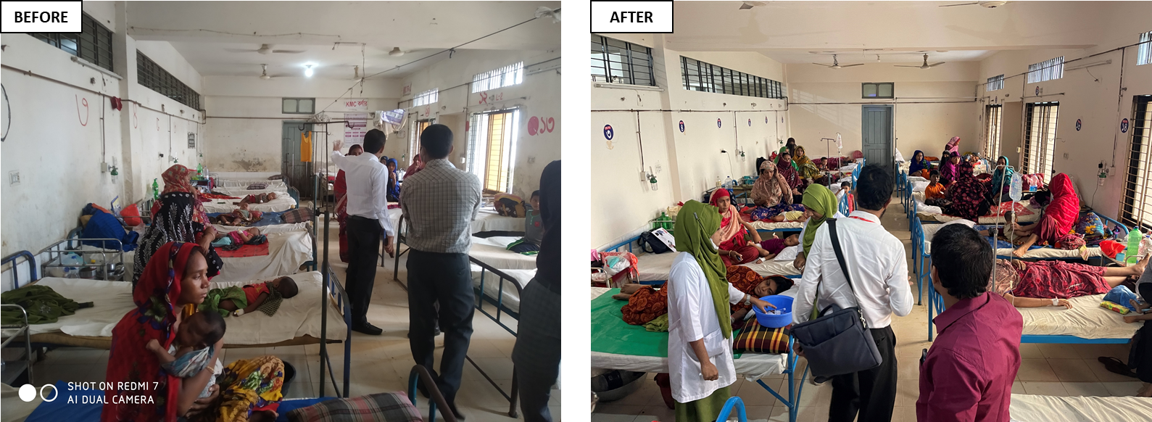

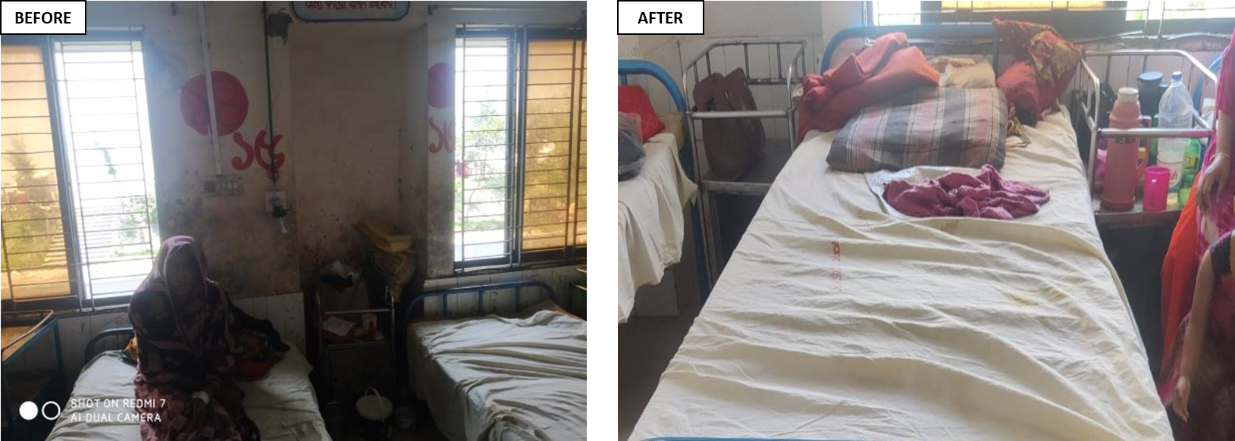

Fig-2-5: Positive changes in Female Ward

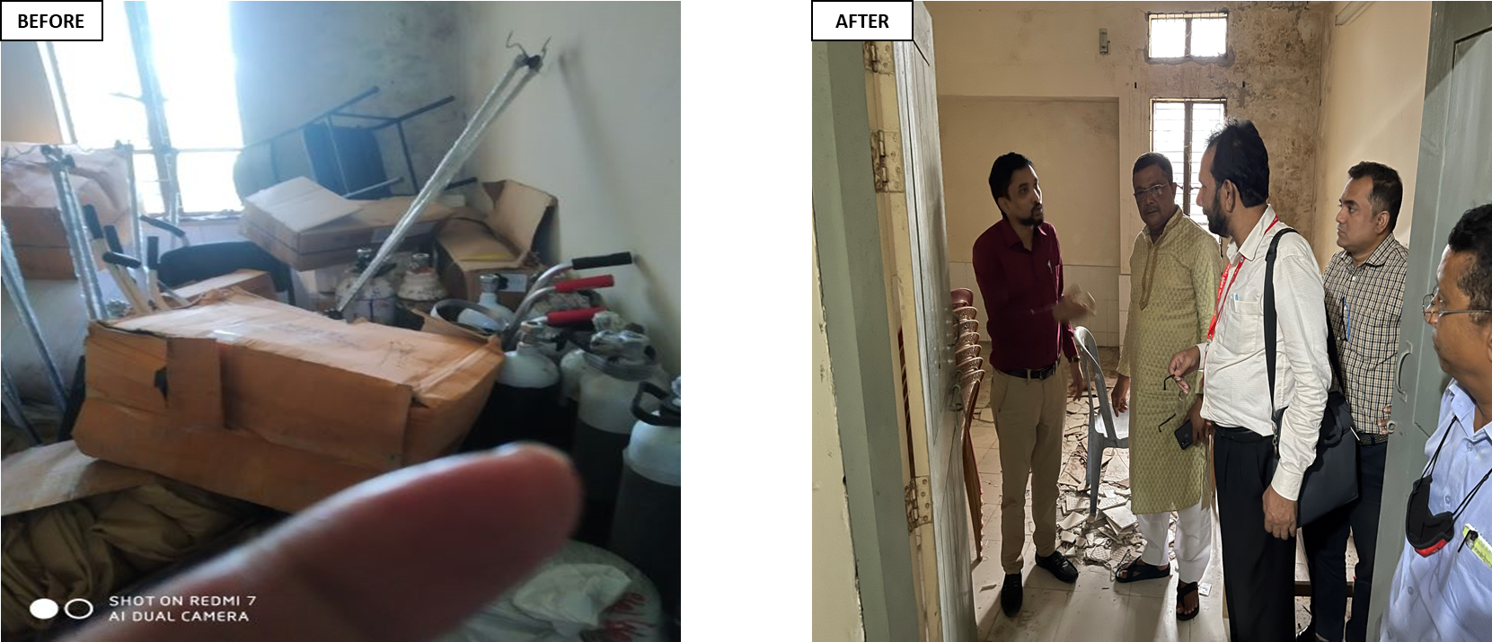

Fig-6,7: Removal of unwanted items for Labour room

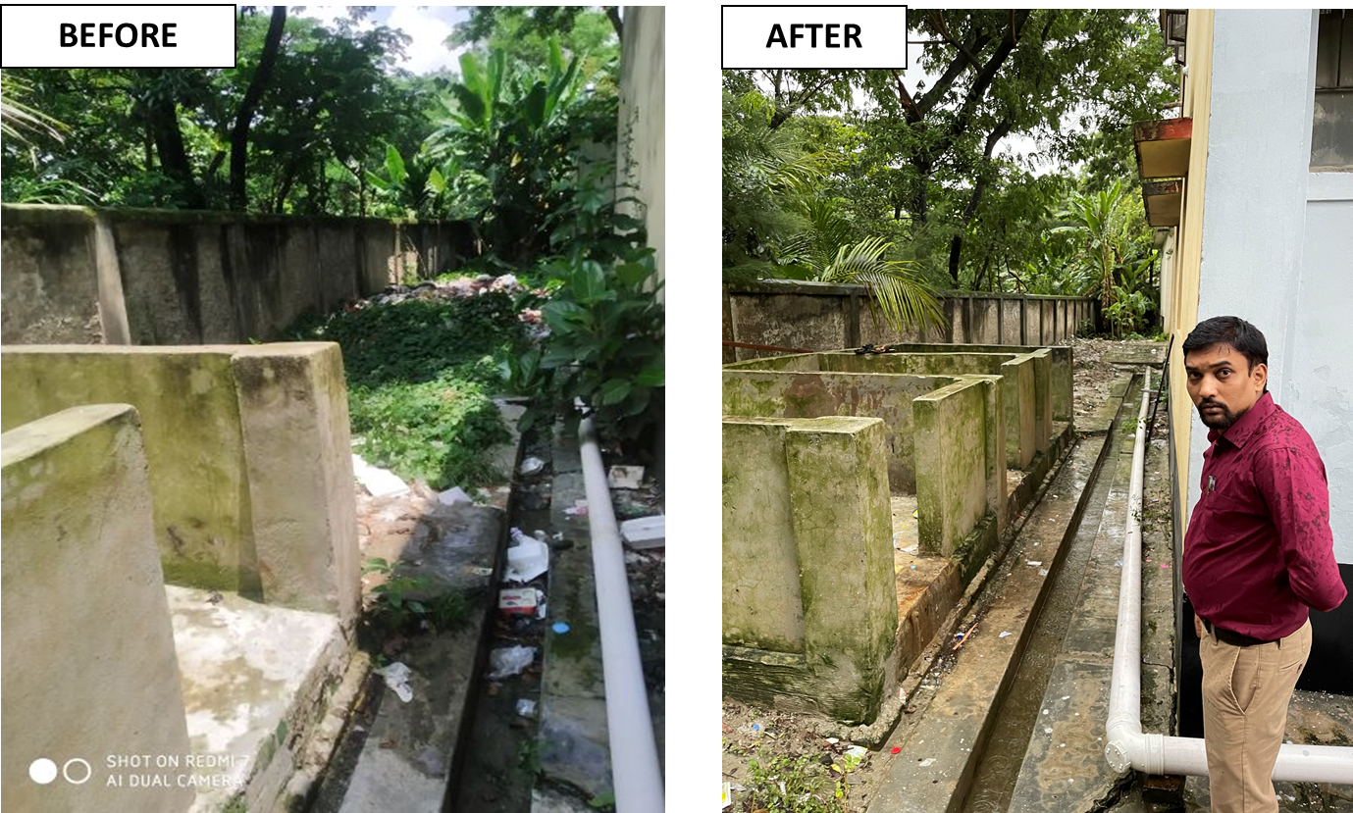

Fig-8,9: Improvement of waste management system

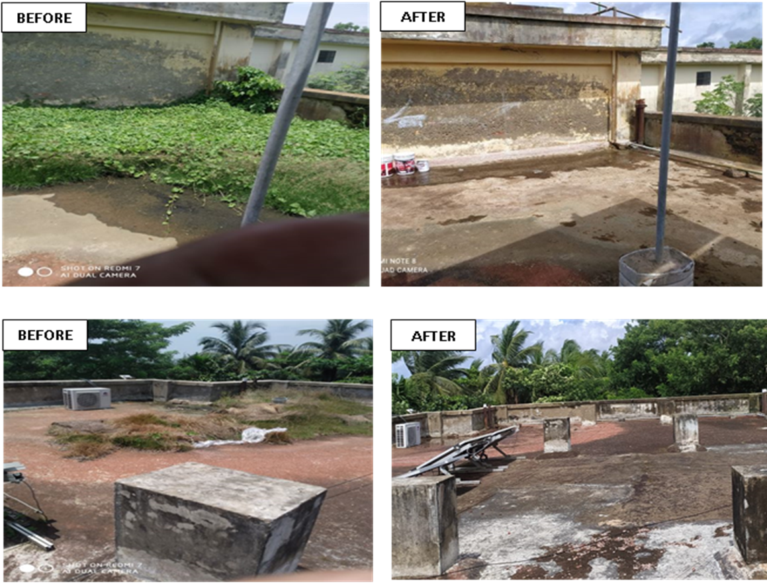

Fig-10-13: Changes in the rooftop of the UHC

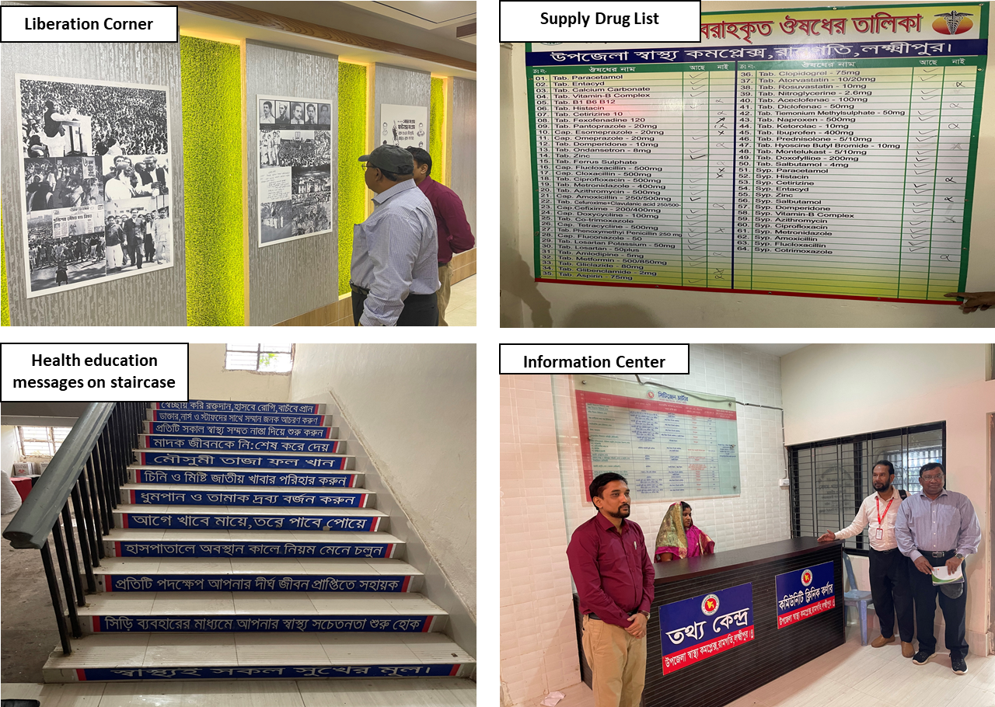

Fig-14-17: Innovation of Ramgati UHC

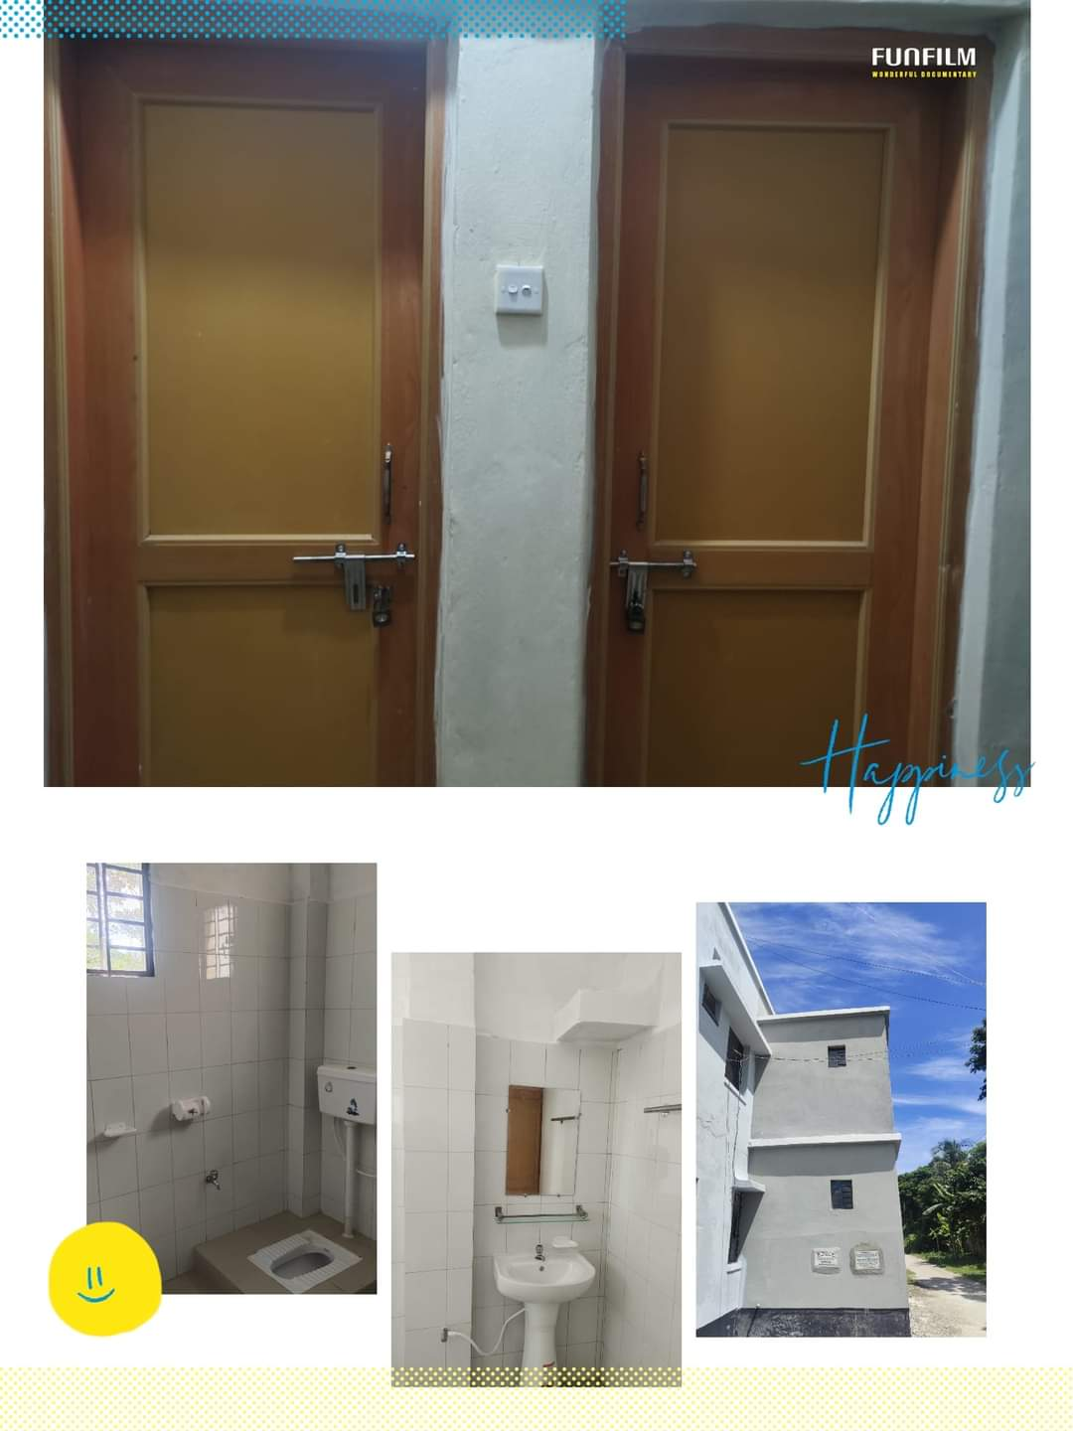

Fig-18: Newly constructed 4 washroom for patients
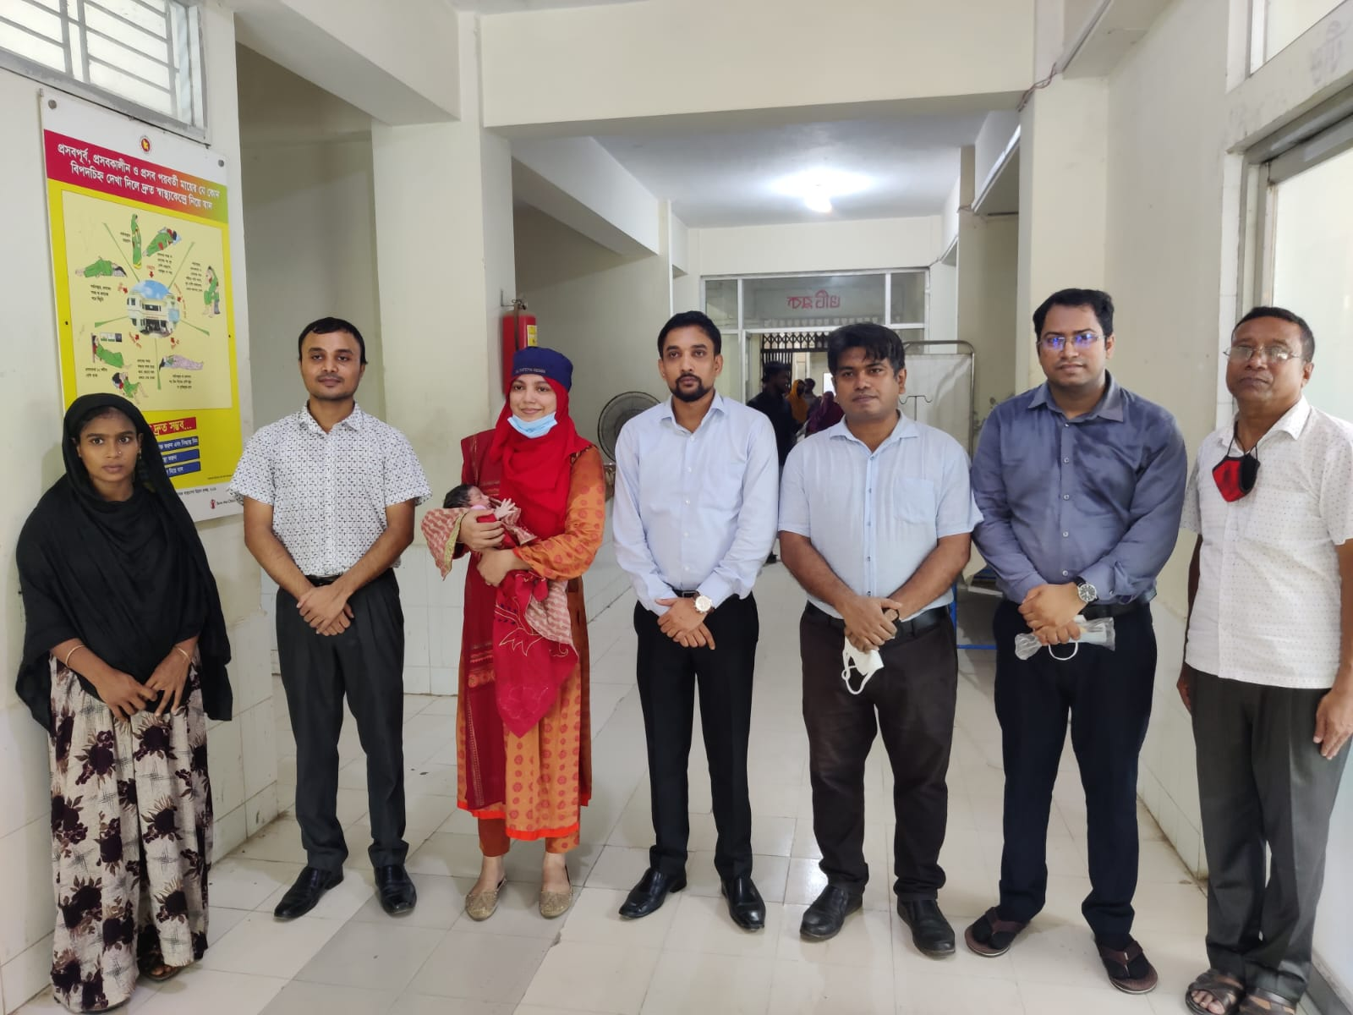

Fig-19: C-section restarted by the support of Civil surgeon

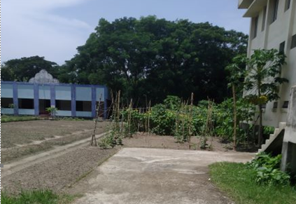

Fig-20: Vegetable Garden in UHC Campus

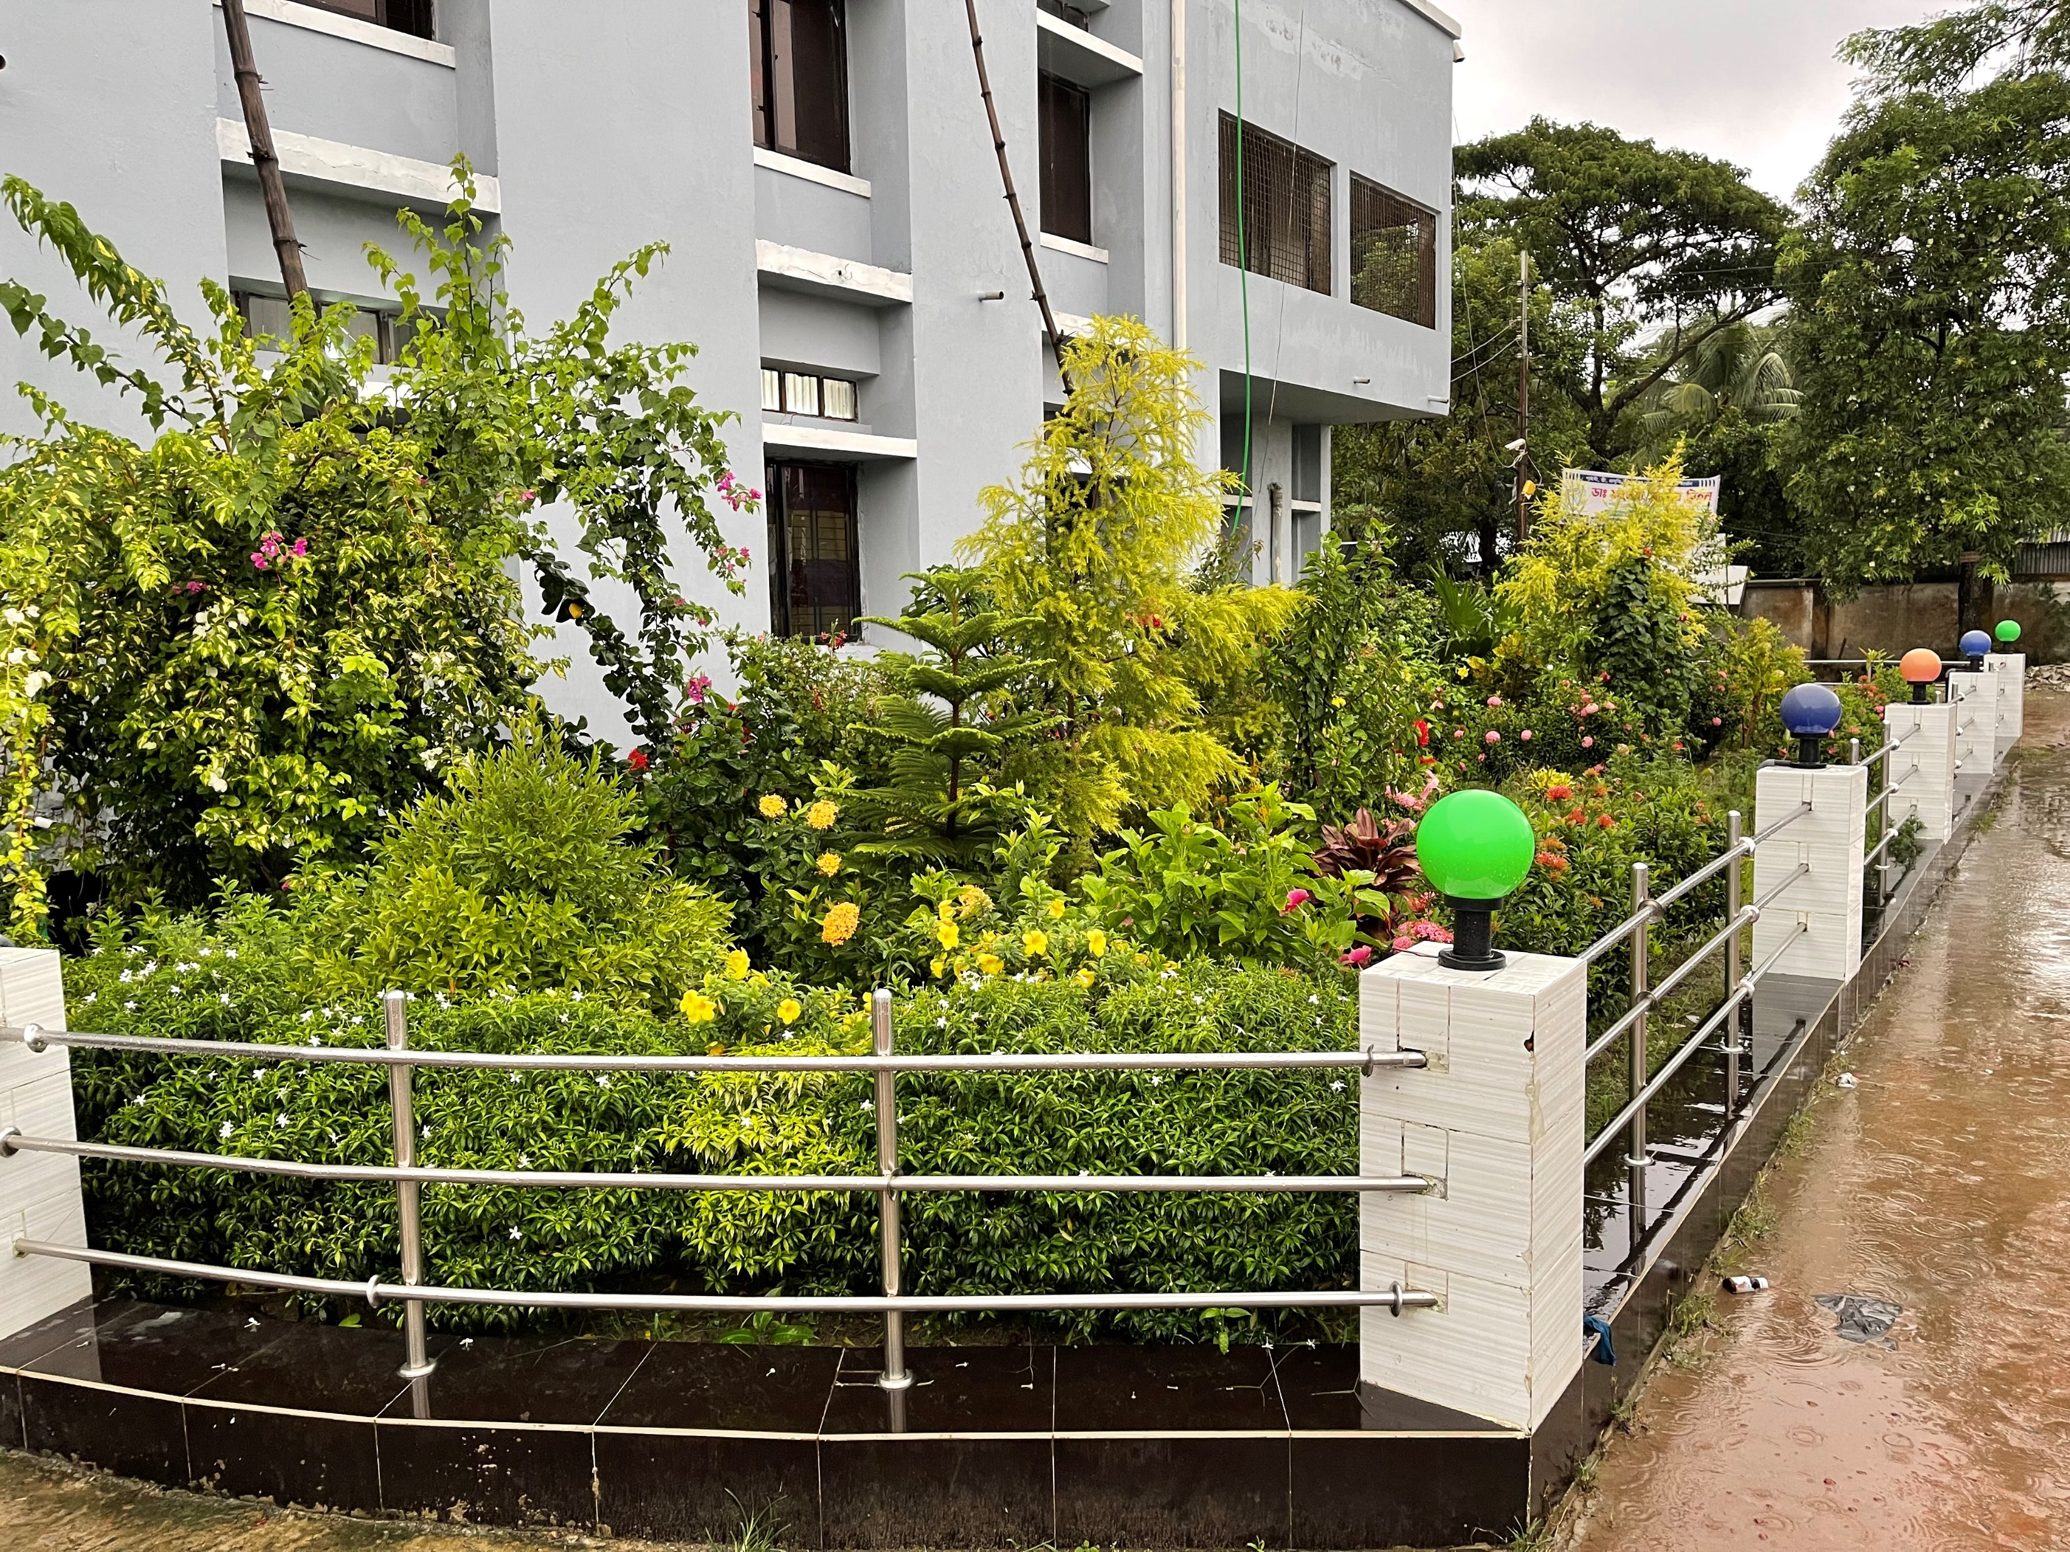
Fig-21: Beautiful Garden in front of UHC

Recommendation:
1. The post of Gynae consultant should be filled immediately to develop effective maternal health services.
2. The UHC is 31 bedded hospital. The bed occupancy rate of the hospital is more than 100%. So, rooftop of the hospital can be used for ward and administrative offices by forming tinshed infra-structure.
3. There are two places selected for SSK booth and pharmacy which needs reconstruction.

